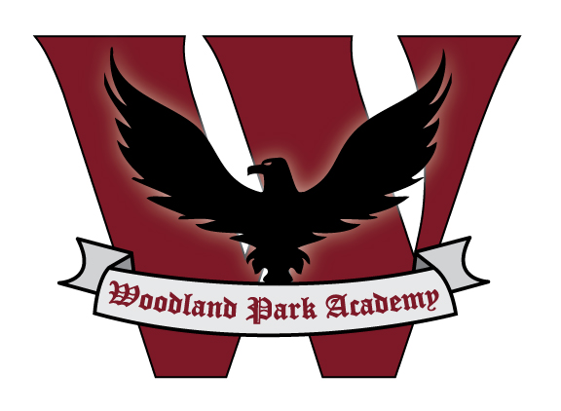
Woodland Park Academy

School Annual Education Report (AER) Cover Letter

February 15, 2017

Dear Parents and Community Members:

We are pleased to present you with the Annual Education Report (AER) which provides key information about the 2015-2016 educational progress for Woodland Park Academy. The AER addresses the complex reporting information required by federal and state laws. The school’s report contains information about student assessment, accountability and teacher quality. If you have any questions about the AER, please contact Jeremy Brown for assistance. Additionally, directions for understanding the scorecard display are available here.

The AER is available for you to review electronically by visiting the following web site; https://goo.gl/P62aC1 or PDF or you may review a copy in the principal’s office at your child’s school.

For the 2016-17 year, no new Priority or Focus schools were named; some Priority or Focus schools did exit their status because they met the exit criteria. New Reward schools were identified using school rankings and Beating the Odds information. A Focus school is one that has a large achievement gap between the highest and lowest achieving 30% of schools. A Priority school is one whose achievement and growth is in the lowest 5% of all schools in the state. A Reward school is one that has achieved one or more of the following distinctions: top 5% of schools on the Top-to-Bottom School Rankings, top 5% of schools making the greatest gains in achievement (improvement metric), or “Beating the Odds” by outperforming the school’s predicted ranking and/or similar schools. Some schools are not identified with any of these labels. In these cases no label is given.

Woodland Park Academy has not been given one of these labels. However, we were given a status of “Lime” in the Michigan Department of Education’s color coding system.

A summary of Woodland Park Academy’s Core Subject M-STEP results are listed below. The data compares proficiency M-STEP data from the Spring of 2015, Spring 2016 to Woodland Park Academy’s ‘Composite Resident District’, to the ‘Local District’ (Grand Blanc Community Schools), to the ‘State Average.’ To clarify, the ‘Composite Resident District’ is a formula of the resident districts, to which our students would normally be enrolled. For example, 65.1% of our students reside in the Flint City School District, 11.3% reside in Grand Blanc School District, 6.5% reside in Carman-Ainsworth Community Schools, etc.

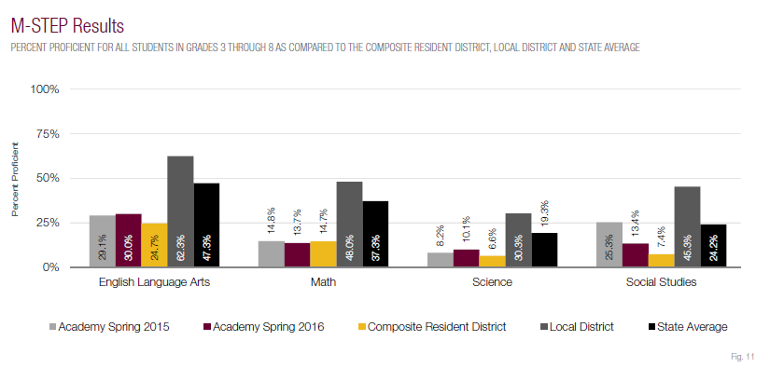

Subgroup analysis of M-STEP results are listed by English Language Arts and Math.

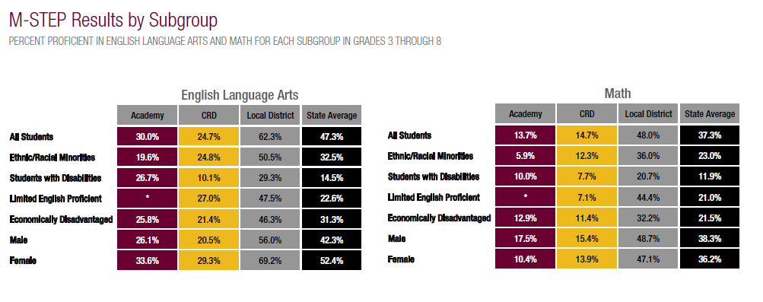

Key challenges at Woodland Park Academy are within the areas of math and science.

Woodland Park Academy has identified a continued need for improvement in math as evident by Michigan’s Student Test of Educational Progress (M-STEP). As a whole, the district has a high need for math improvement, especially with ethnic/racial minorities and female students. In order to increase student growth in math, Woodland Park Academy is addressing Tier I instruction--the instruction provided to all students. We also continue to ensure curriculum alignment, provide ongoing professional development with teaching staff, and provide consistent use of the accompanying academic vocabulary to continue an upward trend in all forms of data. Targeted instruction is provided to students struggling with math concepts and meeting benchmark goals throughout the year. In-school and after school instruction is being provided to students that qualify for additional support.

To impact the identified science content need, we will strengthen our curriculum through the careful analysis and alignment of the State’s newly adopted Next Generation Science Standards. Science teachers will be provided ongoing training with the new science standards and staff will work in professional learning communities to align science instruction across the content areas. Science teaching staff will also pilot new science curriculum that align with the new science standards. Further, we will address the demographic achievement discrepancies through strengthening our Multi-Tiered System of Support and monitor learner outcomes for all students and subgroups.

This multi-faceted approach to accelerating student achievement, coupled with our Multi-tiered System of Support will strengthen the learner outcomes at Woodland Park Academy and help to close achievement gaps identified in the data analysis.

State law requires that we also report additional information.

- PROCESS FOR ASSIGNING PUPILS TO THE SCHOOL
The process for admission of students is outlined by our Board of Directors. Students who reside in Michigan will be permitted enrollment. Space is limited and thus students must enroll each school year. When enrolling students who have already been enrolled and those with a sibling who has already been enrolled will be given preference during the enrollment process. Once a grade level has reached the maximum enrollment students will be placed on a wait list. When space becomes available students from the wait list will be enrolled.
The Board of Directors authorizes the Director to deny admission to any student who has a record of behavior the Director believes would constitute a threat to the safety and well-being of fellow students and staff.

Enrollment trends are indicated below.
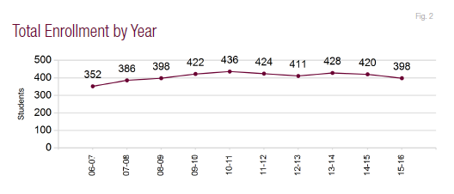

- THE STATUS OF THE 3-5 YEAR SCHOOL IMPROVEMENT PLAN
The School Improvement process is approached by a multi-tiered team at Woodland Park Academy. We solicit the input of our parents, students, staff and board when compiling our School Improvement Plan. This year our School Improvement Plan has themes that permeate each of the goals. Theme one is to provide an aligned curriculum. This is done through efficient use of school time by maximizing teacher common planning and execution of cross-curricular activities. Theme two is to ensure that the aligned curriculum is being delivered with the highest possible instructional quality. This is accomplished through observations, feedback, mentoring, professional development and evaluation using Charlotte Danielson’s Framework for Teaching (2013). The final theme upon which our School Improvement Plan is built is that of an individualized approach. We will accomplish this through the very well established multi-tiered system of support provided by our Positive Behavior Intervention Support department in coordination with our Response to Intervention team. This last theme is also founded in the differentiation of lessons provided by the classroom teachers. Our school team meets weekly to discuss the progress being made in these realms and ultimately our School Improvement Plan.
- A BRIEF DESCRIPTION OF EACH SPECIALIZED SCHOOL

Woodland Park Academy is a single-building district.

- IDENTIFY HOW TO ACCESS A COPY OF THE CORE CURRICULUM, A DESCRIPTION OF ITS IMPLEMENTATION, AND AN EXPLANATION OF THE VARIANCES FROM THE STATE’S MODEL

Curriculum documents are accessible in our school office and on our school website: http://woodlandparkacademy.org/curriculum/about-our-curriculum/. Our school Curriculum Director can provide additional information, as needed. As indicated in our School Improvement Plan, written curriculum documents are currently being aligned and updated with Common Core Standards.
WPA Curriculum: Woodland Park Academy offers a cohesive curriculum that follows state and national Common Core standards of education.
Reading: Classroom teachers use the “workshop method” of instruction to deliver balanced literacy. Students are engaged in activities throughout the day that include phonemic awareness, phonics, direct instruction in vocabulary, fluency, and comprehension strategies. A high level of engagement is encouraged and time spent reading is essential at WPA. ALL students are assessed 3 times per year and progressed monitored to ensure that they are meeting the state and national benchmarks.
Writing: Classroom teachers use the “workshop method” to deliver writing instruction. Students use writing notebooks and publish multiple pieces of work. The teacher delivers writing instruction based on content & ideas, organization, style, voice, and conventions.
Handwriting: Students are explicitly taught print and cursive handwriting in Kindergarten through Fifth Grades. A “verbal path” is used to direct students through letter formations and handwriting paper is provided for students to practice these skills. WPA teachers understand that handwriting fluency is an essential skill that needs to be mastered to aid in the writing process.
Word Study/Spelling: Teaching students how to spell is important. Teachers facilitate the study of words, word parts, word meaning, and the exploration of spelling patterns. Students make their own discoveries through sorting and organizing words based on patterns they observe. Assessments and spelling within written assignments clearly indicate the level of achievement students have attained.
Mathematics: WPA has a strong mathematics curriculum which emphasizes computational and procedural skills, problem solving, communicating, reasoning and proof, making connections, and using representations to prepare students with the mathematical skills they will need in everyday life, as well as the demands of high school. As the students gain fact fluency in our K-2 program in computational and procedural skills, they begin to develop a deeper understanding of the mathematical concepts and reasoning required for problem solving. Students learn to represent and communicate ideas through the use of signs, symbols, models, graphs, and terms. Students investigate and analyze problems and possibilities using logical thinking, reasoning, and proofs.
Science: Woodland Park Academy utilizes one fully equipped science lab for middle school students and science teachers that teach students in kindergarten through fifth grade. Students participate with hands-on, experiment-based instruction that provides opportunities for reading, writing and discussion. Physical, Life, and Earth sciences are intensely taught with lessons that include referencing, investigations and laboratory practices as well as lessons that incorporate the writing process for research projects. These will prepare science students for a competitive high school career.
Social Studies: Michigan Citizenship Collaborative Curriculum (MC3) units are sequenced and appropriate for students. The major goal of the curriculum to enable students to acquire and use sophisticated disciplinary forms of thinking, key social studies (historical/geographical/political/economic) big ideas, concepts and conceptual frameworks, important vocabulary and literacy skills and relevant historical, geographic, political, and economics facts. In helping students learn to use more sophisticated thinking using new concepts and facts, and new intellectual and literacy skills, the curriculum will always build upon and develop students’ background knowledge and give them tools to help them think.
Music: Fine Arts are encouraged and valued at Woodland Park Academy. Students in Kindergarten through Fifth grades participate in a weekly class to develop a love of music and desire to learn more about it. Music is presented through all modes of learning: singing, moving, seeing, listening, playing and creating. Students participate in musicals each year. Upper elementary students can choose to learn an instrument and continue instruction through middle school. Middle school musicians perform twice a year. Strings courses are offered for students beginning in Second Grade and continuing until graduation.
Technology: Woodland Park Academy is equipped with a full technology lab and portable tablets and Chromebooks. Students are taught keyboarding skills, uses and purposes of computer technology, online resources, web-based programs, computer hardware and working with software programs such as Microsoft Word, Excel, and PowerPoint.
Middle School Electives: Students in middle school choose 2 electives per marking period. Options include; technology, leadership, archery, sports, band, strings, teaching tolerance, current events, advanced strings, art, advanced art, dance, reading support, math support, and Lego robotics. Electives differ every marking period, depending upon the needs of the students and skills of the instructors.
5. THE AGGREGATE STUDENT ACHIEVEMENT RESULTS FOR ANY LOCAL COMPETENCY TESTS OR NATIONALLY NORMED ACHIEVEMENT TESTS
Third through eighth grade students at Woodland Park Academy took the NWEA MAP assessment three times during the 2014-2015 school year. This data is used to measure the student growth with respect to learner objectives. In reading the average RIT scores were as follows: kindergarten 153, first grade 173.3, second grade 177.8, third grade 192.1, fourth grade 199, fifth grade 210, sixth grade 210.3, seventh grade 218.1, and eighth grade 215.7. In math the average RIT scores were as follows: kindergarten 152.8, first grade 174.6, second grade 180.5, third grade 193.8, fourth grade 201.7, fifth grade 212.1, sixth grade 214.4, seventh grade 217.7, and eighth grade 218.4. These are nationally norm referenced assessments that the staff uses to determine areas of need for each student.

To complete the two year comparison the students took the NWEA MAP assessment three times during the 2015-2016 school year. This data is again used to measure the student growth with respect to learner objectives. In reading the RIT scores were as follows: kindergarten 153.5, first grade 172.6 second grade 185.1, third grade 194.4, fourth grade 201.3, fifth grade 207.1, sixth grade 212.1, seventh grade 218.6, and eighth grade 223.3. In math the average gains were as follows: kindergarten 152.6, first grade 176.6, second grade 187.3, third grade 193, fourth grade 202.1, fifth grade 208.1, sixth grade 209.8, seventh grade 220.4, and eighth grade 222.5. These are nationally norm referenced assessments that the staff uses to determine areas of need for each student.
6. IDENTIFY THE NUMBER AND PERCENT OF STUDENTS REPRESENTED BY PARENTS AT PARENT-TEACHER CONFERENCES
The percentage of parents attending the parent/teacher conferences are:
2014-2015: 73.16% (300/410)
2015-2016: 77.85% (312/400)
At Woodland Park Academy we take a great deal of pride in the relationships we have worked so hard to develop with every member of our community. These relationships add a tremendous level of agility and institutional confidence to every conversation. Our Board of Directors works diligently with Woodland Park Academy staff to ensure that all decisions are best for the educational experience and outcomes of our students. Our multifaceted plan of aligning or curriculum, ensuring instructional quality, and individualizing the student experience to maximize the educational opportunities in all classrooms will continue to leverage gains for all members of our community!
Sincerely,
Jeremy Brown

Sources Referenced

2015-2016 M-STEP & MME: A supplement to the academic performance report, Woodland Park Academy. The Governor John Engler Center for Charter Schools, Central Michigan University.

mischooldata.org. State of Michigan Center for Educational Performance and Information.

